SuperMatch Student Reference Guide

Overview
Equipping Students with More Tools to Find Best-Fit Colleges
The SuperMatch college search tool within Naviance makes it even easier for students to explore their options and discover colleges that are a match with their academic profile and a fit with what they’re looking for in a college experience.

Using SuperMatch
SuperMatch can be found by navigating to Colleges Home > Find Your Fit.
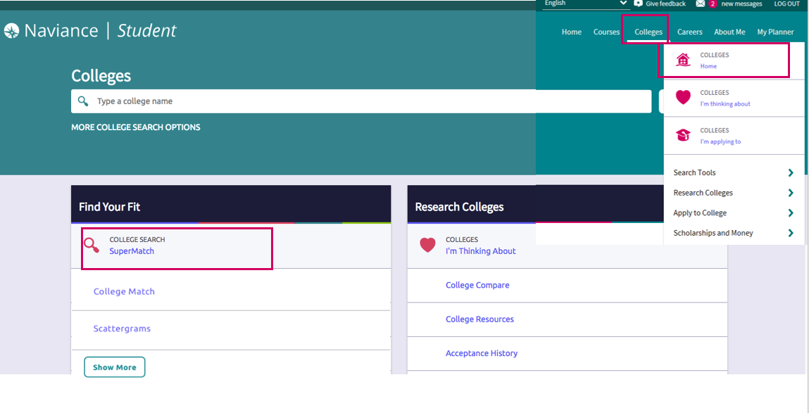

Quick Tips
When you first log in to SuperMatch, you will be guided through a series of quick tips to help you navigate the search tool and understand the key features. Also, clicking on the About SuperMatch link in the top right corner of the page will relaunch the quick tips should you get stuck and need assistance.
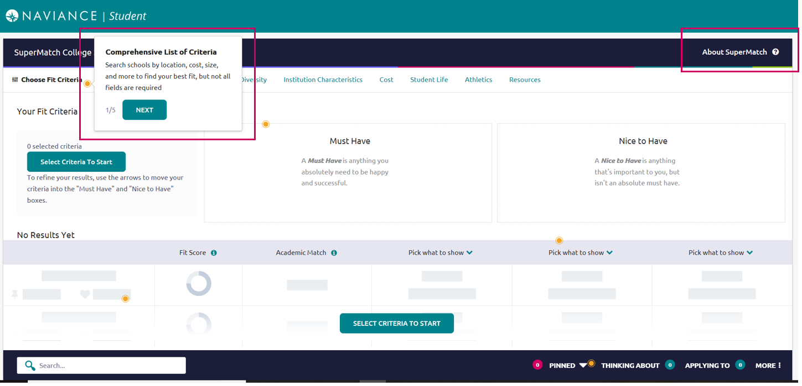

Selecting Fit Criteria
- Use the Choose Fit Criteria navigation menu at the top to select criteria based on what you are looking for in your college experience. You do not need to select something under every category; only select the criteria which are most important
to you.
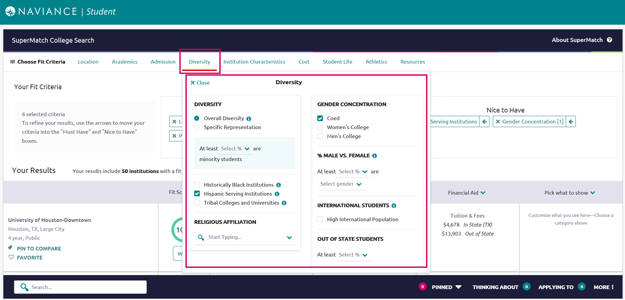

- Click on the Tool Tips icon throughout the search tool to read definitions for common concepts and terminology.
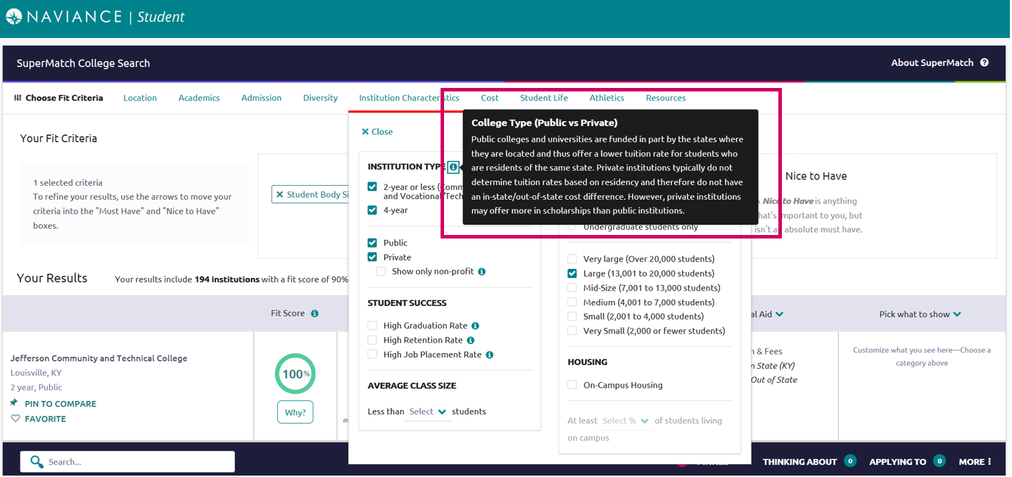
- As fit criteria are selected, they populate in the Must Have box. You can also move criteria between the Must Have and Nice to Have boxes depending on level of importance to you. Moving your criteria between these two categories of importance will refine your college search results below.
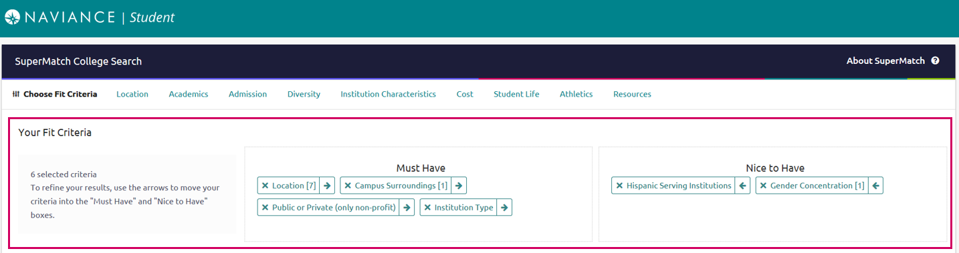

Search Results
Institutions with the highest Fit Score will always appear at the top of your list. To see your Fit Score Breakdown based on the criteria you selected, click on the green Why? box located under the Fit Score percentage.
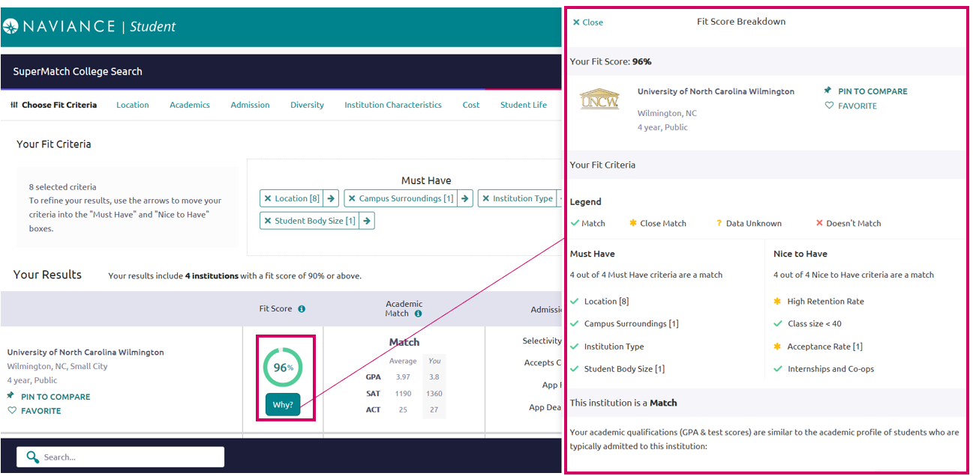

GPA, SAT, and/or ACT scores will be pre-populated as part of the Admissions fit criteria, if available within Naviance. If not available, you can enter your information to see how you compare to institutional averages in the Academic Match column. Note: GPA’s are converted to a 4.0 scale.

By clicking on the green arrow next to the results table headings, you can also pick which content appears in the results table.

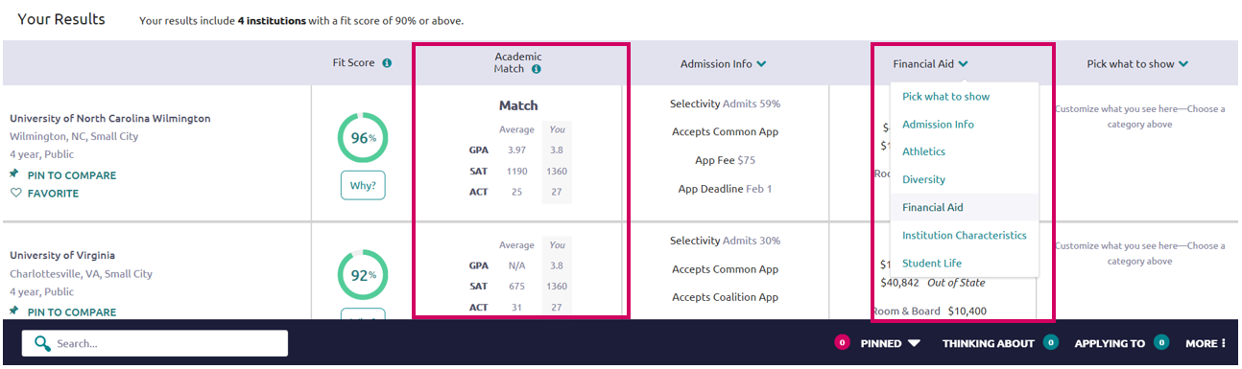

Comparing Pinned Schools
While viewing your results, you can Pin to Compare to see a comparison of those colleges which interest you. As you select each college to compare, the pinned colleges will appear at the top of the results table with a purple bar next to it.
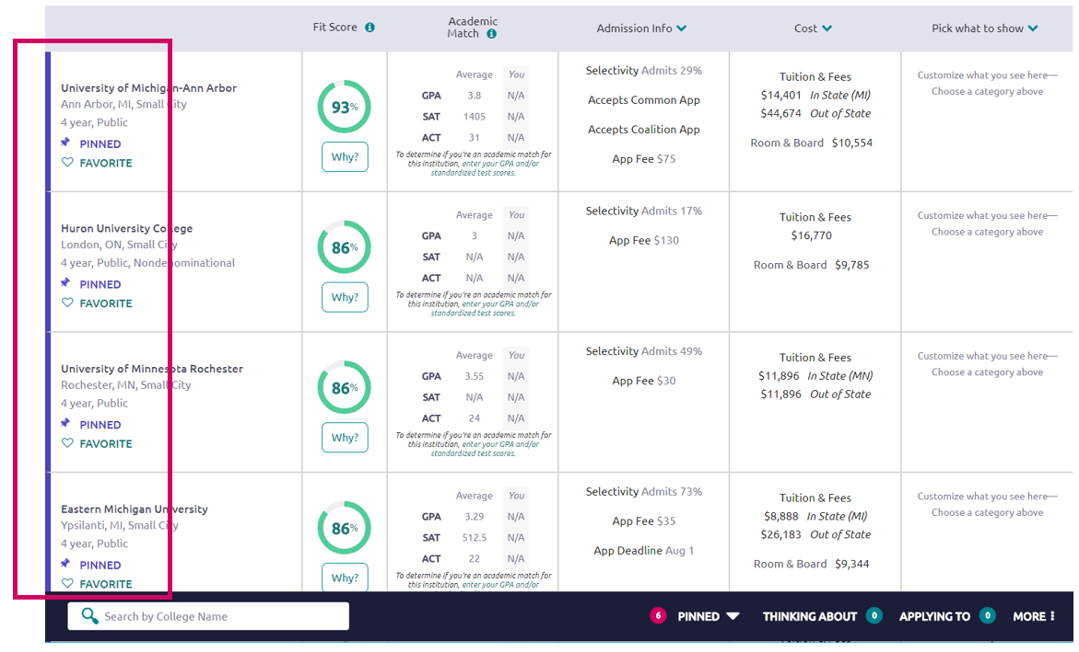

To see an in-depth side-by-side comparison, click on the Pinned menu in the bottom right corner and select Compare Pinned Colleges. Once on the compare pinned page, you can export your results by clicking on the green Export button located near the top right corner.
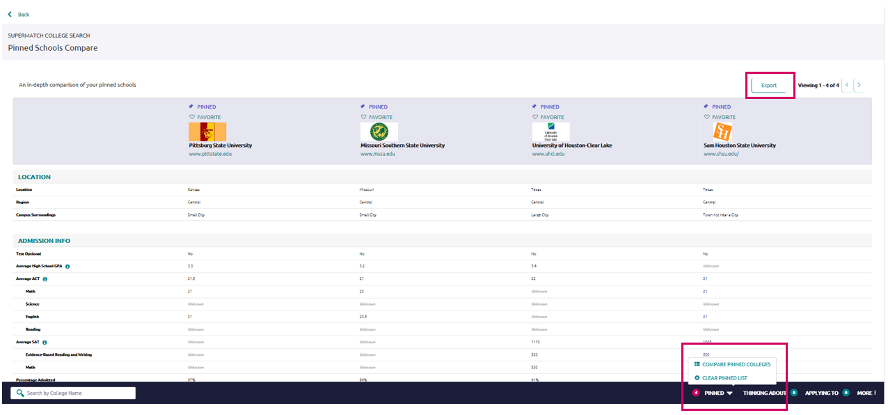

More

By clicking on the More menu in the bottom right corner, you will see two options. Upcoming Visits will take you to a page showing all college visits scheduled at your high school, while Events will take you to a page listing events that colleges have scheduled on their campus.

Colleges Interested in You

To learn more about colleges that are looking for students like you, click Interested in You on the bottom navigation menu.

